**PREDICT FLIGHT  
  
Idea**

This app is great for notifying you in advance about a probable delay in your flight.  All you have to do is create an account and then enter you originating airport and destination airport, the flight number (your complete itinerary).

* *Predict Flight* will predict if its safe to travel on those days using weather forecast information.
* Also, if the weather seems favorable then but the flight chosen by the user is getting delayed lately, it will notify the user in advance that the flight is getting delayed and that it is wise to cancel or reschedule as early as possible.
* Will daily notify user with the latest status updates (is the weather clear or not?) on the flight.

This can be done using a **predictive engine which takes into account weather and airport performance data (fuzzy logic and machine learning algorithms)** to score the itinerary.  Should a delay be predicted, it will even ask the user to reschedule the flight or cancel reservations? There is nothing worst than flying into a connecting airport only to get stranded there for days. *Predict Flight* can help avoid these nightmare scenarios.

**Potential users**

Passengers: For checking the weather before confirming reservation

Airline crew: For checking the weather forecasts beforehand and automatically cancel during those days. This was it can prevent causing trouble to future travelers as flight will not be listed for those days.

**Problems Solved**

* The notifications of the app can help the user to cancel/reschedule the flight at the earliest thus, saving money.
* Users will be able to track their flights all the time and avoid booking flights.
* Also, can entirely avoid the scenario described in the description of the exercise
* Also, if the user has to reach a place on time and for sure, then using the app he can decide to choose a flight flying through a different route.
* Also airlines can know beforehand and cancel the flights preventing inconvenience to its customers altogether.
* Also, checking the app before booking flight saves money

**Features**

* Flight Search Engine
* Map with weather forecast integrated for the scheduled date providing an interactive interface and providing a general overview of the climate of that region so as to decide whether should reschedule the flight or cancel the trip itself.
* Pattern showing the delays of the flight in the recent week which shows the probability of the flight being delayed in the coming weeks
* Weather details of each layover station considering the weather forecast predictions not only at origin and destination but at each connecting station too.
* Final prediction based on flight delay pattern and weather forecast for that day.
* Notification feature allows for notifying user if there is sudden change in weather or delay pattern and alerting user to take the appropriate action.

Also, can later on add features to cancel, book and reserve flight through this app redirecting the users to the fight carrier website.

Low Fidelity Prototype:

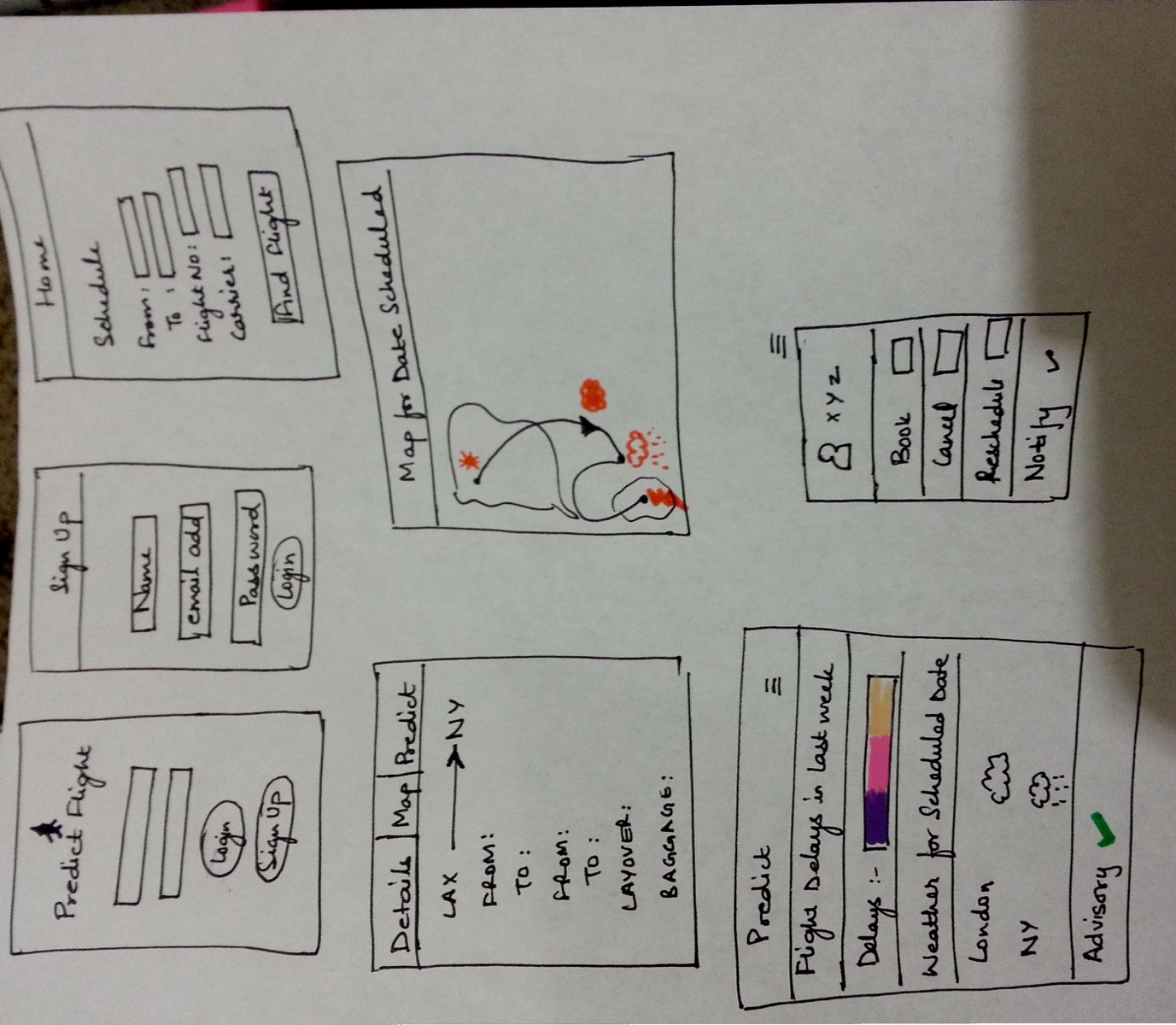

High Fidelity prototype is attached as a movie file